ProposalForge
A Versatile, Domain-Aware RAG Copilot for Finance, Healthcare & Agriculture
Ask anything across three very different worlds in one chat. ProposalForge detects the domain you mean, retrieves grounded knowledge from that domain only, and replies with inline citations plus smart, domain-tuned suggestions for what to ask next.
CAPSTONE PROJECT DOCUMENT
Project type: Multi-domain conversational RAG assistant · Stack: Streamlit (frontend) · Azure (backend)
Domains: Finance · Healthcare / Hospitalization · Agriculture

OVERVIEW

One copilot, three domains, zero guesswork
Most assistants are built for a single subject. ProposalForge is built to be versatile: a single chat surface that confidently serves three knowledge domains that have almost nothing in common — personal finance, hospital and health-insurance processes, and agriculture. The hard part of “versatile” is not answering questions; it is knowing which domain a question belongs to, retrieving from the right knowledge, and applying the right tone and guardrails for that domain. That routing problem is what ProposalForge is designed around.
The product does three things well. First, it auto-routes — a domain router classifies each message and, when intent is ambiguous, autosuggests the likely domain so the user confirms with one tap instead of digging through menus. Second, it keeps each domain’s knowledge in its own retrieval namespace, so a finance answer is never contaminated by agricultural data and a health answer respects stricter privacy rules. Third, every reply is grounded: answers carry inline citations to the source documents, and the assistant proposes domain-tuned follow-up questions to keep the conversation productive.

Current challenge | What users do today | ProposalForge’s answer
Knowledge lives in silos | Open a different tool or portal per domain | One chat, auto-routed to the right domain
Wrong-domain answers | Re-phrase, retry, lose trust | Router + autosuggest confirm intent first
Unverifiable replies | Cross-check sources manually | Inline citations on every grounded claim
Sensitive data handling | Inconsistent, manual caution | Per-domain guardrails (PHI/PII, no advice)

SECTION 1

Project definition

1.1 Project type
ProposalForge’s primary archetype is a chatbot — a conversational question-answering and task assistant. On top of that core it carries three sub-skills that make it versatile rather than generic: a domain router that classifies and autosuggests, a summariser that condenses long source documents, and a recommender that surfaces the most relevant next questions and resources for the active domain.
Domain Router | Chatbot core | Summariser | Recommender
Primary differentiator | Primary archetype | Sub-skill | Sub-skill
Classify intent → pick domain | Conversational Q&A / tasks | Condense long sources | Surface relevant next steps
Autosuggest when ambiguous | Tool-calling RAG agents | Map-reduce over chunks | Embeddings + business rules
Keeps a human in control | Clarifies before answering | Feeds clean intent to retrieval | Suggests follow-ups & assets

1.2 Goals
- Serve three distinct domains — finance, healthcare/hospitalization, and agriculture — from one conversational interface, with no domain feeling like a second-class citizen.
- Route correctly and transparently: detect the domain of each query and, when unsure, autosuggest the domain for one-tap confirmation rather than guessing silently.
- Stay grounded: answer only from indexed, domain-scoped knowledge and attach inline citations to every factual claim.
- Guide the conversation: after each answer, propose domain-tuned follow-up questions and, where useful, suggest a relevant other domain.
- Respect domain rules: apply per-domain guardrails (no unlicensed financial advice, no medical diagnosis, privacy-safe handling) consistently.
Success measures
- Domain-routing accuracy ≥ 95% on a labelled evaluation set across the three domains.
- Citation coverage ≥ 95% of factual claims grounded to a verifiable source.
- Answer groundedness (faithfulness) score ≥ 0.9 on automated evals.
- Autosuggest acceptance: a measurable share of users accept a suggested domain or follow-up question.
- Retrieval precision@5 and P95 retrieval latency < 3s per query.

1.3 Non-goals
- Not a licensed advisor — ProposalForge informs and explains; it does not give regulated financial advice, medical diagnoses, or binding legal opinions.
- Not an open-web search engine — it answers from curated, indexed domain knowledge, not the live internet.
- Not a transactional backend — placing trades, filing insurance claims, or purchasing inputs are out of scope for the build; the assistant explains the process and links out.
- Not an unbounded domain set — the build targets exactly three domains; adding a fourth is a configuration exercise, not a goal of this phase.
- Not a fine-tuned model project — versatility comes from routing and retrieval, not from training a bespoke model per domain.

1.4 Feature definition
The feature set divides into a shared conversational core, the signature autosuggest / routing layer, and per-domain capabilities.
Core & signature features
- Domain auto-routing — classifies each message and selects the matching knowledge namespace and persona.
- Autosuggest (three layers) — a domain suggestion when intent is ambiguous; type-ahead question completion drawn from the active domain; and follow-up suggestions after each answer.
- Grounded answers with citations — every claim links back to its source chunk.
- Clarification loop — when a mandatory detail is missing, the copilot asks a targeted question instead of hallucinating.
- Add-knowledge upload — drop a document into a domain and it is ingested, tagged, and made searchable.
Per-domain capability map
Domain | Example tasks | Key knowledge sources | Guardrails
Finance | Explain loan eligibility; compare investment products; summarise a policy or statement | Product docs, regulatory FAQs (RBI/SEBI), policy PDFs, glossaries | No personalised investment advice; cite source; add disclaimer
Healthcare / Hospitalization | Cashless claim steps; admission & discharge process; insurance coverage Q&A | Hospital policies, insurer claim guides, patient FAQs, care instructions | No diagnosis; PHI/PII-safe; escalate to professionals
Agriculture | Crop & pest advisory; government scheme eligibility; market-price context | Crop advisories, scheme documents, agronomy guides, price feeds | Note local variation; cite source; advisory not guarantee

1.5 Target users
User | Needs | Active domain
Retail customer / borrower | Plain-language answers about products, eligibility and process | Finance
Patient / caregiver | How to navigate admission, claims and discharge without jargon | Healthcare
Farmer / extension worker | Timely, source-backed crop, pest and scheme guidance | Agriculture
Support / knowledge lead | Add new documents and trust that answers stay grounded | All three

1.6 UI mock
The interface is a single Streamlit chat. A left rail lets the user pin a domain or leave it on auto-route; the centre is the conversation with citation chips on answers; and the highlighted element is the autosuggest panel that proposes domain-tuned questions as the user types. Switching domains never means switching apps.
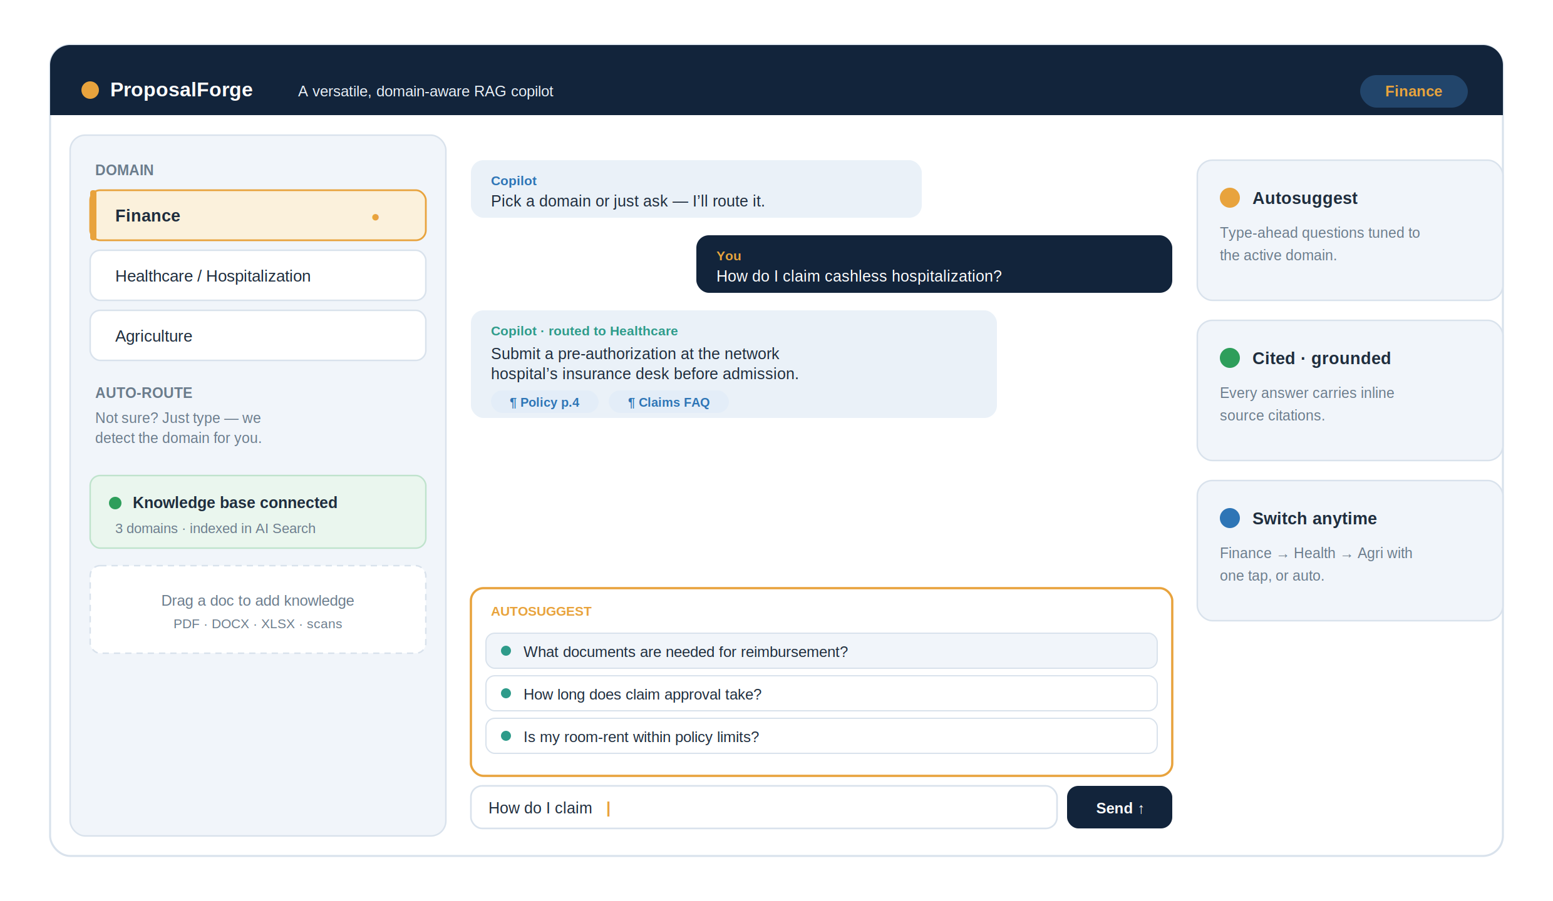
Figure 1 — ProposalForge Streamlit interface: domain rail, auto-route, citations and the autosuggest panel.

SECTION 2

Design architecture
ProposalForge is an agentic RAG system on Azure. A single orchestration layer receives every message, decides which domain it belongs to, retrieves from that domain’s knowledge, composes a grounded answer, and returns suggestions. Shared services (model, vector store, search) are used by all domains, but knowledge is partitioned per domain by namespace and metadata.

2.1 End-to-end system architecture
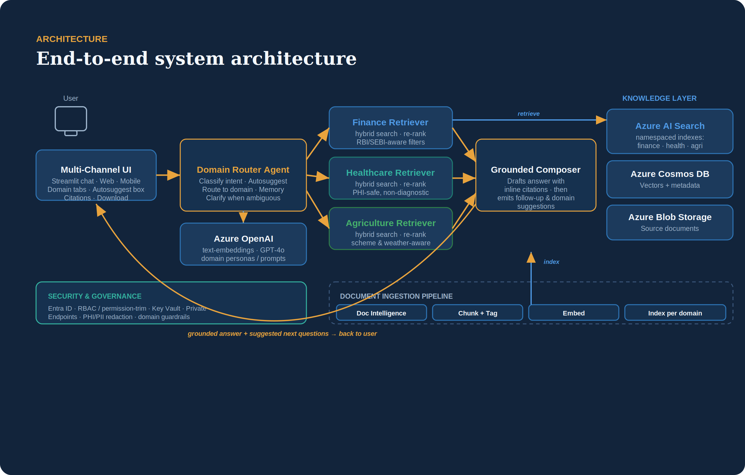
Figure 2 — End-to-end architecture: UI → Domain Router → per-domain retrievers → grounded composer, over a shared Azure knowledge layer.
A message enters through the multi-channel UI and reaches the Domain Router Agent, which classifies intent and routes to one of three domain retrievers. Each retriever runs hybrid search (keyword + vector) against its own namespace in Azure AI Search, backed by Cosmos DB vectors and Blob-stored source documents. The Grounded Composer drafts the answer with inline citations and hands off to the suggestion service before the response returns to the user. Cross-cutting bands provide security and governance (Entra ID, RBAC, Key Vault, PHI/PII redaction) and observability (tracing, groundedness and quality evals).

2.2 Domain routing & the autosuggest mechanism
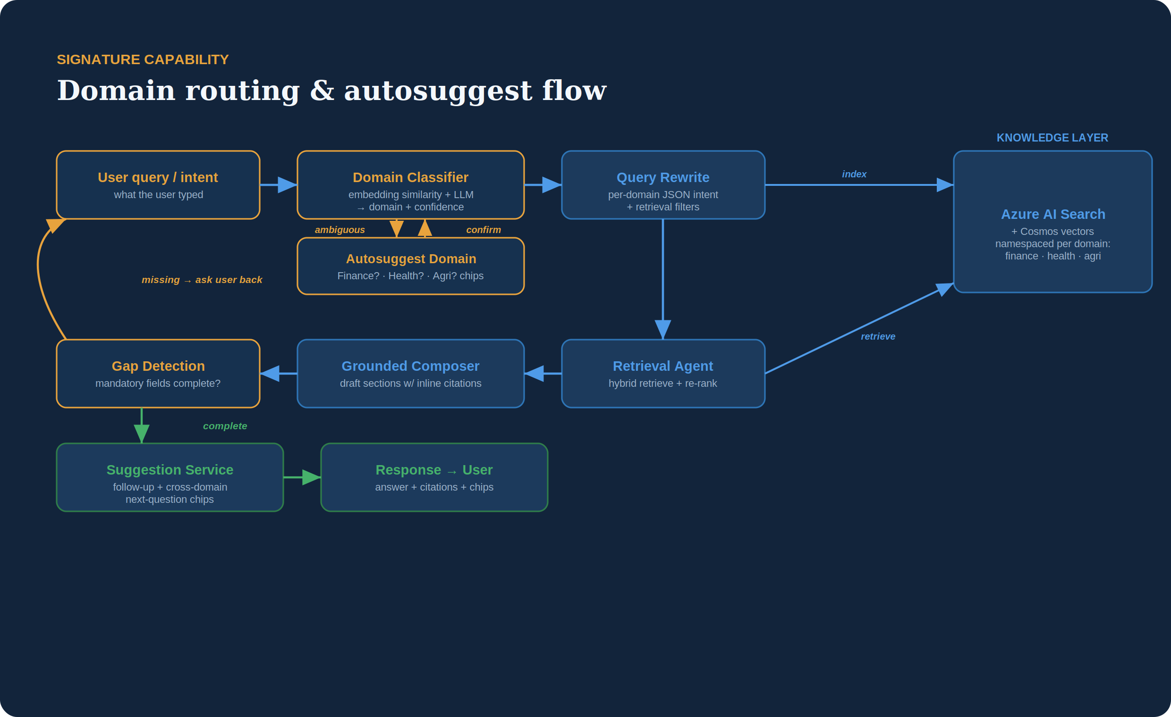
Figure 3 — The signature flow: classify → (autosuggest if ambiguous) → retrieve → compose → suggest.
Routing is the heart of the system, and autosuggest operates at three distinct points so the assistant feels both versatile and in control:
- 1) Domain autosuggest. The classifier combines embedding similarity to each domain’s centroid with a lightweight LLM check, producing a domain plus a confidence score. Above a threshold it routes silently; below it, the UI surfaces “Looks like Healthcare — switch?” chips so the user confirms in one tap.
- 2) Query type-ahead. As the user types, the suggestion service offers completions drawn from the most relevant indexed questions in the active domain, so users discover what the knowledge base can actually answer.
- 3) Follow-up suggestions. After each grounded answer, the composer proposes 2–3 next questions tuned to the domain, and may suggest a hop to another domain when the query implies it (e.g. a hospitalization cost question that touches finance).
If a mandatory detail is missing, gap detection pauses generation and asks the user a precise question rather than fabricating an answer; once complete, the answer is composed and returned with citations and suggestions.

2.3 Multi-domain ingestion pipeline
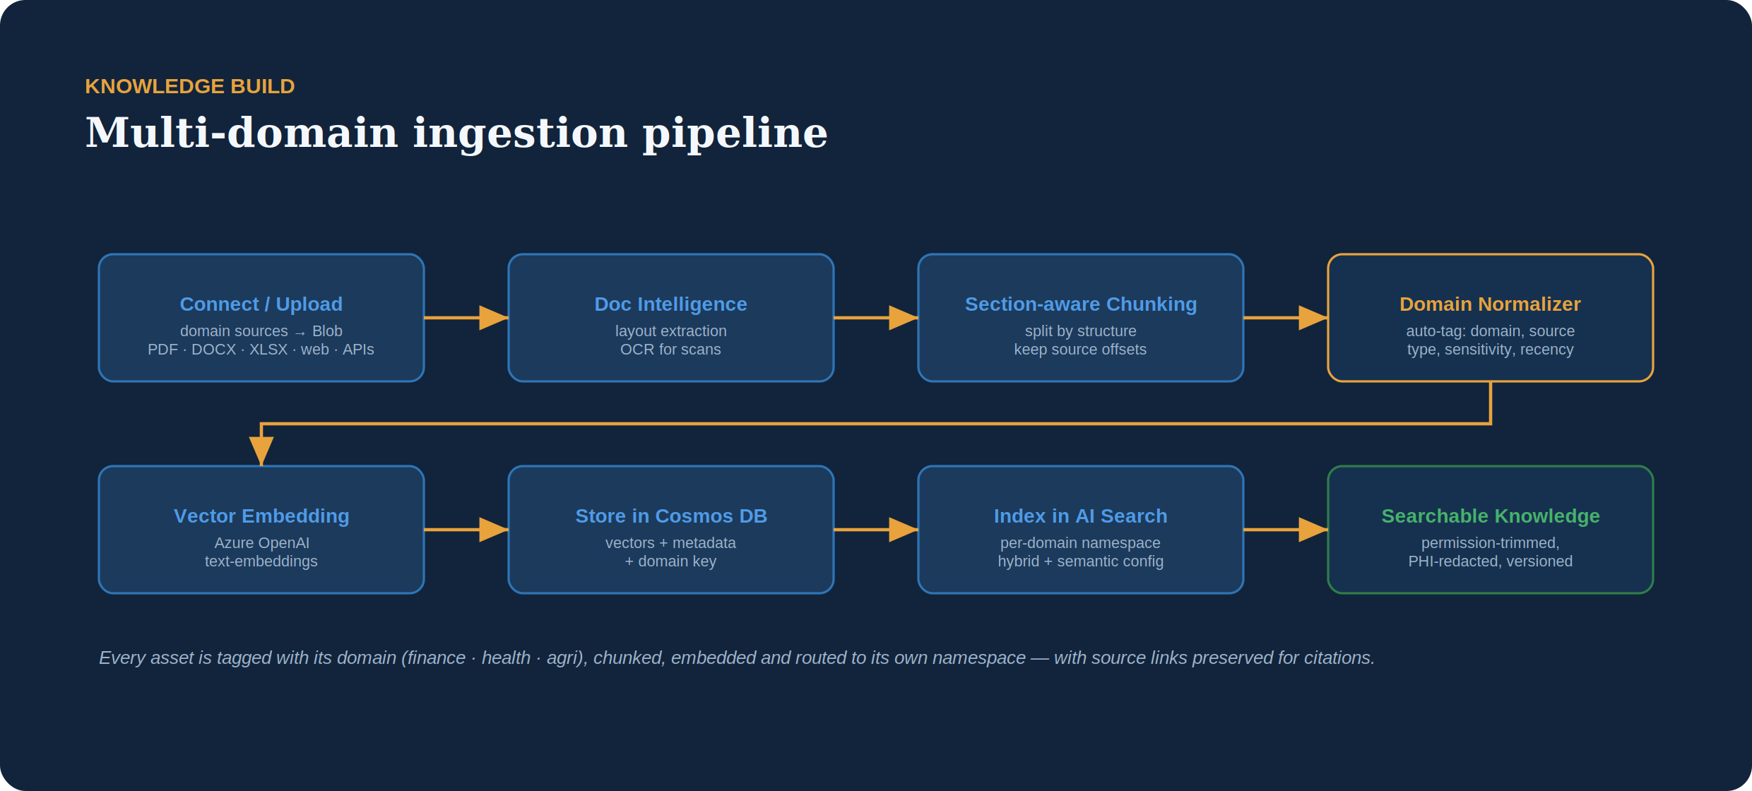
Figure 4 — Ingestion: documents are extracted, chunked, domain-tagged, embedded and indexed into per-domain namespaces.
Knowledge enters via upload or connected sources and flows through Azure Document Intelligence for layout extraction (with OCR for scans), section-aware chunking that preserves source offsets for citations, and a Domain Normalizer that auto-tags each chunk with its domain, source type, sensitivity and recency. Chunks are embedded with Azure OpenAI, stored in Cosmos DB with their domain key, and indexed into the matching namespace in Azure AI Search — permission-trimmed, PHI-redacted where needed, and versioned.

2.4 Per-domain knowledge & guardrails
Domain | Retrieval scoping | Guardrail behaviour
Finance | Finance namespace; filter by product, region, regulator | Refuses personalised advice; appends “informational only” note; always cites
Healthcare | Health namespace; filter by insurer/hospital, document type | Never diagnoses; redacts PHI/PII; routes urgent cases to professional help
Agriculture | Agri namespace; filter by crop, region, season, scheme | Flags local/seasonal variation; cites advisory source; avoids guarantees

SECTION 3

Agent architecture
Behind the domain router, ProposalForge runs five cooperating agents. One operates at ingestion time; the other four operate at request time under an orchestrator. The roles are framework-agnostic — Semantic Kernel, LangGraph or AutoGen all work — and the domain router sits in front, choosing the sector before the request-time agents engage.
Agent | Type | Responsibility | Runs on
Orchestrator Agent | Planner / router | Plans the run, routes between agents, holds conversation memory, drives the clarification loop | Azure Functions (Durable) / Container Apps
Reasoning Agent | Analyst | Interprets the request, extracts metadata filters, maps requirements to sections, detects gaps | Azure OpenAI (GPT-4o)
Retrieval Agent | Tool-calling | Hybrid retrieval + metadata filtering + semantic re-ranking | Azure AI Search / Cosmos DB
Action / Generation Agent | Tool-calling | Composes grounded sections with citations; calls the format builders | Azure OpenAI + Functions
Document Normalizer | Ingestion agent | At upload: extracts layout, chunks, auto-tags metadata, embeds & indexes | Azure Functions
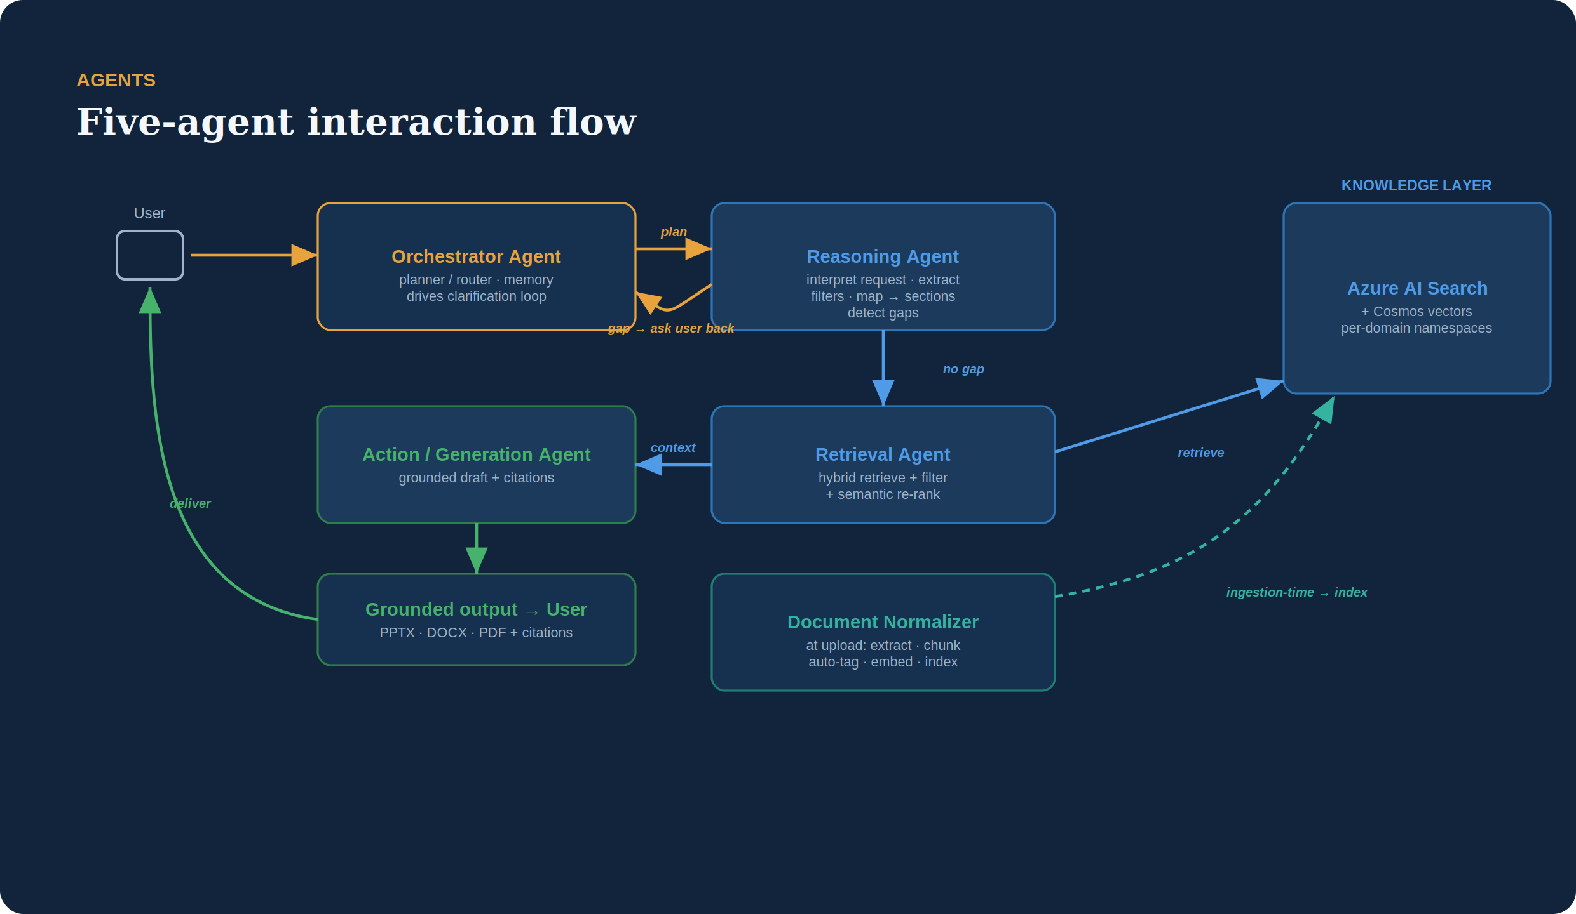
Figure 5 — The five agents and how they hand off, with the clarification loop and ingestion-time normalizer.

How the agents interact
- Orchestrator — the control loop: receives the request, decides which agent runs next, keeps short-term memory, and crucially decides whether to pause and ask the user (clarification) or proceed.
- Reasoning — reads the input, produces a structured requirement checklist, extracts filters (sector, content-type, skills, years), maps each requirement to a section, and flags any mandatory field with no grounded source — the gap-detection signal.
- Retrieval — for each section query, runs hybrid retrieval against Azure AI Search and Cosmos DB, applies permission-trimming and metadata filters, then semantically re-ranks the candidates.
- Action / Generation — drafts each section grounded in the retrieved context with inline citations, assembles a structured key–value map, and renders the chosen format (PPTX / Word / PDF).
- Document Normalizer — the ingestion-time agent that turns any uploaded file into searchable, embedded, metadata-tagged knowledge with source links preserved.

SECTION 4

Technology stack
The stack is intentionally Azure-native so the whole system runs inside one tenant with consistent identity, security and observability.
Frontend | Orchestration & AI | Knowledge & data | Platform & ops
Streamlit chat app | Azure OpenAI (GPT-4o + embeddings) | Azure AI Document Intelligence | Key Vault · Private Endpoints
Domain rail + auto-route | Semantic Kernel / LangChain agents | Azure AI Search (hybrid + semantic, per-domain) | Microsoft Purview (governance)
Autosuggest / type-ahead | Domain router + classifier | Azure Cosmos DB (vector store) | Application Insights (observability + evals)
Citations + suggestion chips | Azure Functions (Durable) / Container Apps | Azure Blob Storage (sources) | CI/CD via GitHub Actions / Azure DevOps
Auth via Microsoft Entra ID | Prompt + tool routing layer | Per-domain metadata & RBAC trimming | Azure Content Safety (output gating)

Why these choices
- Azure AI Search namespaces give clean per-domain isolation without standing up three separate stores.
- Azure OpenAI is shared across domains; versatility comes from per-domain prompts and retrieval filters, not separate models.
- Durable Functions / Container Apps host the agentic loop with retries and state for the clarification flow.
- Entra ID + RBAC + Purview let permission-trimming and audit work uniformly across all three domains.

SECTION 5

GitHub repository
A single monorepo keeps the shared core and the per-domain configuration together. Domains are configuration and knowledge, not forks of the codebase — the same retrieval and generation code serves all three.

github.com/your-org/domainpilot

domainpilot/
├─ app/ # Streamlit frontend
│ ├─ main.py
│ ├─ components/ # chat, autosuggest, citations
│ └─ domain_rail.py
├─ router/ # the signature layer
│ ├─ classifier.py # embeddings + LLM intent
│ ├─ autosuggest.py # domain + query + follow-ups
│ └─ confidence.py
├─ ingestion/
│ ├─ extract.py # Doc Intelligence
│ ├─ chunk.py
│ ├─ normalize.py # domain / metadata tagging
│ └─ embed.py
├─ retrieval/
│ ├─ orchestrator.py # classify · retrieve · act
│ ├─ hybrid_search.py
│ ├─ rerank.py
│ └─ gap_detection.py # clarification loop
├─ domains/ # config + guardrails, no logic forks
│ ├─ finance.yaml
│ ├─ healthcare.yaml
│ └─ agriculture.yaml
├─ generation/ # grounded composer + citations
├─ shared/ # config · auth · logging
├─ infra/ # Bicep IaC
├─ tests/
└─ requirements.txt

Conventions
- Trunk-based development with short-lived feature branches and required PR review.
- Each new domain is added by dropping a YAML config + its source set — no change to retrieval or generation code.
- CI runs lint, unit tests and a retrieval-quality eval gate before merge; CD deploys infra via Bicep.

SECTION 6

Mapping the repo to Azure services
Each module in the repository maps to a managed Azure service, so the architecture diagram and the codebase line up one-to-one.
Repo module | Azure service | Purpose
app/ | App Service / Container Apps | Hosts the Streamlit UI
shared/auth | Microsoft Entra ID | SSO + RBAC identity
router/ (classifier, autosuggest) | Azure OpenAI + Azure Functions | Intent classification & suggestion logic
ingestion/extract | AI Document Intelligence | Layout extraction + OCR
ingestion/embed | Azure OpenAI (embeddings) | Vectorise chunks
ingestion sources | Azure Blob Storage | Store source documents
retrieval (vectors) | Azure Cosmos DB | Vector store + metadata
retrieval (search) | Azure AI Search | Per-domain hybrid + semantic search
retrieval/orchestrator | Azure Functions (Durable) | Agentic loop + clarification state
generation/ | Azure OpenAI + Content Safety | Grounded drafting + output gating
shared/config | Key Vault | Secrets & connection strings
observability | Application Insights | Tracing + groundedness evals
infra/ | Resource Manager (Bicep) | Infrastructure as code

SECTION 7

Evaluation with RAGAS
RAGAS is an open-source framework for evaluating RAG and agentic pipelines. It scores the retriever and the generator separately, so a retrieval problem can be told apart from a generation problem — essential in a regulated setting where an unsupported claim is a real risk.

7.1 Why we need it
- A high faithfulness score with low context recall is a classic trap: the generator answers coherently from partial context while silently missing a requirement. Measuring only generation hides this — so both stages are measured.
- RAGAS turns “the output looks good” into numbers we can gate releases on, tied directly to the project KPIs (citation coverage, requirement coverage).

7.2 Metrics mapped to ProposalForge
RAGAS metric | Stage | What it catches | Target
Faithfulness | Generation | Claims not supported by retrieved context (hallucination) | ≥ 0.95
Response Relevancy | Generation | Answer drifts from the actual requirement | ≥ 0.85
Context Precision | Retrieval | Irrelevant chunks diluting context / wrong ranking | ≥ 0.80
Context Recall | Retrieval | Required information missing from context | ≥ 0.90
Context Entities Recall | Retrieval | Key entities (client, product, dates) not retrieved | ≥ 0.85
Noise Sensitivity | End-to-end | Quality degrading when irrelevant chunks slip in | ≤ 0.20
Factual Correctness | Generation | Draft vs. ground-truth answer (when labelled) | ≥ 0.85
Semantic Similarity | Generation | Draft vs. reference section | ≥ 0.85
Agentic metrics (evaluated on multi-turn traces)
RAGAS metric | What it measures
Tool Call Accuracy | Did the Retrieval / Action agents call the right tools with the right arguments?
Agent Goal Accuracy | Did the run achieve the user’s goal (a complete, on-spec output)?
Topic Adherence | Did the copilot stay within scope and not wander?

7.3 Evaluation dataset
A small golden set of (question → ideal answer) pairs is built from real + synthetic samples across the three domains. Each sample carries:
Field | Meaning
user_input | the section / requirement question
retrieved_contexts | chunks the Retrieval Agent returned
response | the section the copilot drafted
reference | the ground-truth / gold answer (for recall & correctness)

7.4 How agents + RAGAS connect
- Faithfulness validates the Action / Generation Agent — the automated counterpart of the citation-coverage KPI and a complement to the runtime groundedness check.
- Context Recall / Precision / Entities Recall validate the Retrieval Agent and the Document Normalizer’s chunking & tagging choices.
- Tool Call Accuracy / Agent Goal Accuracy / Topic Adherence validate the Orchestrator and the overall multi-agent run.
- Gap detection and RAGAS are complementary: gap detection prevents ungrounded generation at runtime; RAGAS measures grounding quality offline and online.

SECTION 8

Success metrics & KPIs
Two layers run together: product KPIs (the business outcome) and quality metrics (the RAGAS scores from Section 7), so every business goal has an automated signal behind it.

8.1 Product KPIs
Metric | Target | How measured
Turnaround time | −70% vs. baseline (first draft < 1 hr) | Timestamp from upload to first draft
First-draft acceptance | ≥ 60% | % of sections kept with only minor edits
Citation coverage | ≥ 95% | % of factual claims with a valid source
Requirement coverage | ≥ 98% | % of mandatory requirements addressed
Retrieval quality | precision@5 + groundedness | Offline eval set + LLM-graded groundedness
Latency | P95 < 3s retrieval | Application Insights traces
Asset reuse rate | ↑ over baseline | % of content sourced from existing assets

8.2 Quality metrics (linked to RAGAS)
KPI | Backed by RAGAS metric (§7.2)
Citation coverage | Faithfulness ≥ 0.95
Requirement coverage | Context Recall ≥ 0.90 + Context Entities Recall ≥ 0.85
Retrieval quality | Context Precision ≥ 0.80, Noise Sensitivity ≤ 0.20
First-draft acceptance | Response Relevancy ≥ 0.85, Factual Correctness ≥ 0.85
Agent reliability | Tool Call Accuracy, Agent Goal Accuracy, Topic Adherence
Secondary signals
Groundedness score · P95 retrieval latency · reduction in duplicated effort · number of clarification questions per run (a falling trend signals a maturing knowledge base).

SECTION 9

Market research & competitive landscape

9.1 Market size
The proposal / RFP-response software market is estimated at roughly USD 2.9–3.3 billion in 2025–26 and is projected to grow at an ~11–12% CAGR toward USD 7–9 billion by the mid-2030s, with government and BFSI among the leading, most compliance-heavy verticals. Generative and agentic AI is the dominant disruption theme — and adjacent regulated sectors such as healthcare and agriculture follow the same grounded, auditable-AI playbook.

9.2 Competitive landscape
Segment | Representative players | Positioning
Legacy leaders | Loopio · Responsive (RFPIO) · Qvidian (Upland) | Strong content libraries, workflow & governance; AI layered on; human-in-the-loop drafting
AI-native challengers | AutoRFP.ai · Arphie · AutogenAI · Inventive AI | Agentic requirement extraction & first-draft generation; fast onboarding; lighter governance / data control
Adjacent / security | Conveyor · Whistic · SafeBase | Security-questionnaire-led; trust-center profiles

9.3 Where ProposalForge fits
- A clarification loop that asks the user back instead of guessing — reducing hallucination in regulated domains.
- Grounded answers with inline citations and a full audit trail.
- Multi-domain by design — one copilot across finance, healthcare and agriculture, with per-domain knowledge and guardrails.
- Format-flexible output (PPTX / Word / PDF) from one grounded model.
- Built on the organisation’s own Azure tenant for data residency, security and cost control — a build-side alternative to SaaS lock-in.
Sources: Future Market Insights and Fortune Business Insights (2025–26 market sizing); Loopio and Responsive 2026 industry reports. Figures are paraphrased and ranges vary by analyst.

SECTION 10

Team & roles
Five tracks own the project end-to-end. Each track is responsible for its own research, its design choices, and the architecture execution that delivers them — and the team integrates daily against the delivery plan.
Role | Research | Design choices | Architecture execution
Research & Problem Owner | Domain interviews; success metrics; eval set design | Scope fence; routing accuracy targets | Labelled test data; eval harness
Product & UX Design | Conversation & autosuggest usability studies | Domain rail, chips, citation UX | Streamlit UI + flows
AI / Retrieval Engineer | Classifier & retrieval method comparison | Hybrid search, re-rank, thresholds | Router, embeddings, gap detection
Azure Architect & Platform | Service selection; cost & security review | Namespacing, RBAC, private networking | Bicep IaC, observability, evals
Generation & Integration | Grounding & citation techniques | Composer prompts; suggestion logic | End-to-end wiring + demo

Delivery plan (5-day capstone)
Day | Theme | Focus
Day 1 | Frame & data | Problem statement, three-domain corpus, eval set, scope fence
Day 2 | Ingestion | Upload → Doc Intelligence → chunk → normalize/tag → embed → index per domain
Day 3 | Routing & retrieval | Domain classifier, autosuggest, hybrid retrieval + re-rank, gap detection
Day 4 | Generation | Grounded composer, citations, follow-up suggestions, Streamlit chat
Day 5 | Harden & demo | RBAC, content safety, observability, evals; end-to-end demo across all three domains

Why ProposalForge wins
- Genuine versatility — one chat serves three unrelated domains without feeling generic.
- A transparent router with autosuggest that confirms intent instead of guessing.
- Grounded, citation-backed answers with per-domain guardrails users can trust.
- Built on one Azure tenant for consistent identity, security, cost and observability.

